**What are unicast and broadcast?**

**What are the differences between unicast, multicast, and broadcast?**

**1. Unicast**

This type of information transfer is useful when there is a participation of single sender and single recipient. So, in short, you can term it as a one-to-one transmission. For example, a device having IP address 10.1.2.0 in a network wants to send the traffic stream (data packets) to the device with IP address 20.12.4.2 in the other network, then unicast comes into the picture. This is the most common form of data transfer over the networks.

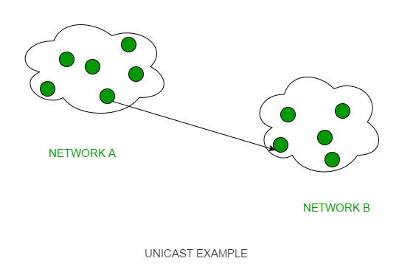

### 2. Broadcast –

Broadcasting transfer (one-to-all) techniques can be classified into two types:

* **Limited Broadcasting –**   
  Suppose you have to send stream of packets to all the devices over the network that you reside, this broadcasting comes handy. For this to achieve, it will append 255.255.255.255 (all the 32 bits of IP address set to 1) called as **Limited Broadcast Address** in the destination address of the datagram (packet) header which is reserved for information transfer to all the recipients from a single client (sender) over the network.

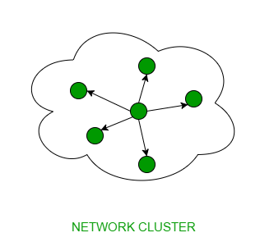

* **Direct Broadcasting**   
  This is useful when a device in one network wants to transfer packet stream to all the devices over the other network. This is achieved by translating all the Host ID part bits of the destination address to 1, referred as Direct Broadcast Address in the datagram header for information transfer.

This mode is mainly utilized by television networks for video and audio distribution.   
One important protocol of this class in Computer Networks is [Address Resolution Protocol (ARP)](https://www.geeksforgeeks.org/computer-network-arp-works/) that is used for resolving IP address into physical address which is necessary for underlying communication.



### ****3-Multicast****

Multicast lets server’s direct single copies of data streams that are then simulated and routed to hosts that request it.

Hence, rather than sending thousands of copies of a streaming event, the server instead streams a single flow that is then directed by routers on the network to the hosts that have specified that they need to get the stream. This removes the requirement to send redundant traffic over the network and also be likely to reduce CPU load on systems, which are not using the multicast system, yielding important enhancement to efficiency for both server and network.

### ****Multicast is true broadcast?****

The multicast source depends on multicast-enabled routers to forward the packets to all clients’ subnets that have clients listening. However, there is no direct affiliation between clients and Windows media servers. The Windows media server creates a “.nsc” (NetShow channel) file when the multicast station is first formed. Usually, the .nsc file is sent to the client from a web server. This file holds data that the Windows media player requires to listen for the multicast.  This is quite the same as fine-tuning a station on a radio. Every client which eavesdrops on the multicast includes no extra overhead on the server. In fact, the server sends out only a single stream per multicast station. The equal load is experienced on the server whether only a single client or multiple clients are listening.

**What are java Generics and wildcards?**

# Wildcards in Java

The question mark (?) is known as the wildcard in generic programming. It represents an unknown type. The wildcard can be used in a variety of situations such as the type of a parameter, field, or local variable; sometimes as a return type. Unlike arrays, different instantiations of a generic type are not compatible with each

**Types of wildcards in Java: -**

1. **Upper Bounded Wildcards:** These wildcards can be used when you want to relax the restrictions on a variable
2. **Lower Bounded Wildcards:**It is expressed using the wildcard character (‘?’), followed by the super keyword, followed by its lower bound: <? super A>.
3. **Unbounded Wildcard:** This wildcard type is specified using the wildcard character (?)

**What is the difference between array list and Enums?**

An Enum is a type whose values are unique named constants. For example, you can think of a Boolean type as an Enum whose values are True and False. A more domain-specific example would be an Enum specifying something like card suits: Spades, Hearts, Clubs and Diamonds. Those are the actual values of the type: you would write `Spades in your code directly, and its type would be Suit where Suit is the Enum.

An array is just an ordered collection of arbitrary elements. It's a data structure that is usually store in one big chunk of contiguous memory.